Big Data Hadoop Project submission on Social Media

**Question – 1 Top 10 most commonly used tags in this data set**

**Solution – 1**

**Pig Script –**

questions_data = LOAD '/user/ebc86e37a5c7b529c82d77dbb24392/VinayT/Datafiles/answers.txt' USING PigStorage('_') AS (c1:chararray,c2:chararray,c3:chararray,c4:chararray,tags:chararray,c6:chararray,c7:chararray,c8:chararray,c9:chararray,c10:chararray,c11:chararray);

tags_data = FOREACH questions_data GENERATE tags;

tags_seperated = FOREACH tags_data GENERATE TOKENIZE(tags);

tags = FOREACH tags_seperated GENERATE FLATTEN($0) AS tag;

tags_group = GROUP tags BY tag;

tags_count = FOREACH tags_group GENERATE group, COUNT(tags) as cnt;

tags_sorted = ORDER tags_count BY cnt DESC;

top10_tags = LIMIT tags_sorted 10;

DUMP top10_tags;

**Output –**

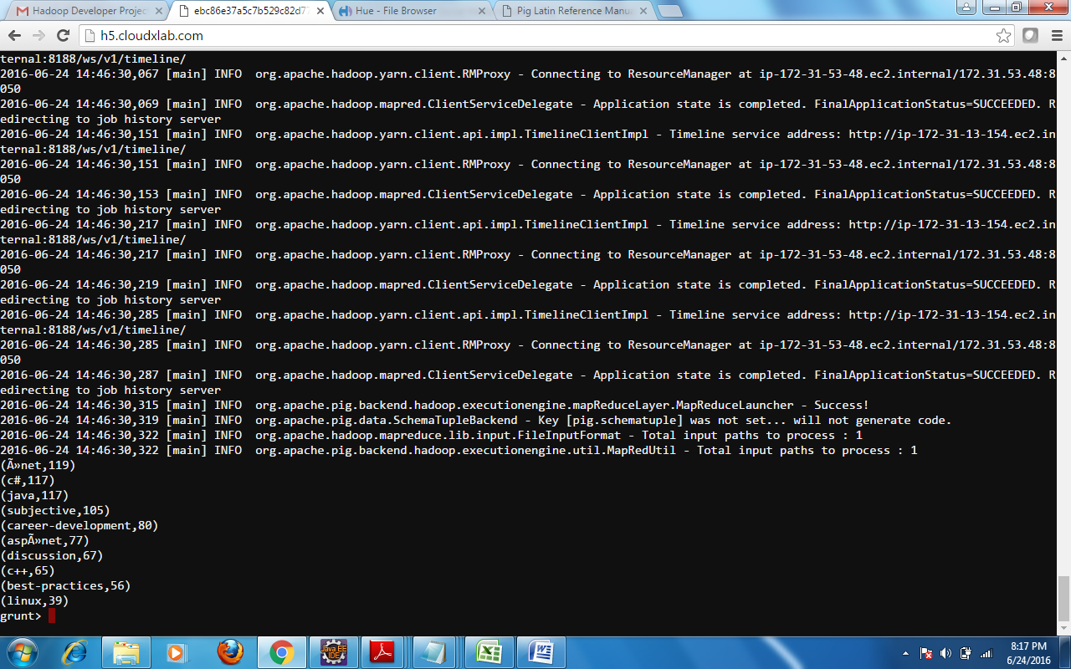

**Question – 2 Average time to answer questions**

**Solution – 2**

**Pig Script –**

questions_data = LOAD '/user/ebc86e37a5c7b529c82d77dbb24392/VinayT/Datafiles/answers.txt' USING PigStorage('_') AS (qid:chararray,c2:chararray,c3:chararray,c4:chararray,c5:chararray,c6:chararray,c7:chararray,c8:chararray,c9:chararray,c10:chararray,at:long);

group_qid = GROUP questions_data BY qid;

avg_qtime = FOREACH group_qid GENERATE group, questions_data.qid as qid, AVG(questions_data.at) as avg;

avg_qtime1 = FOREACH avg_qtime GENERATE qid, ToDate((long)avg*1000) as avg_ans_time;

DUMP avg_qtime1;

**Output –**

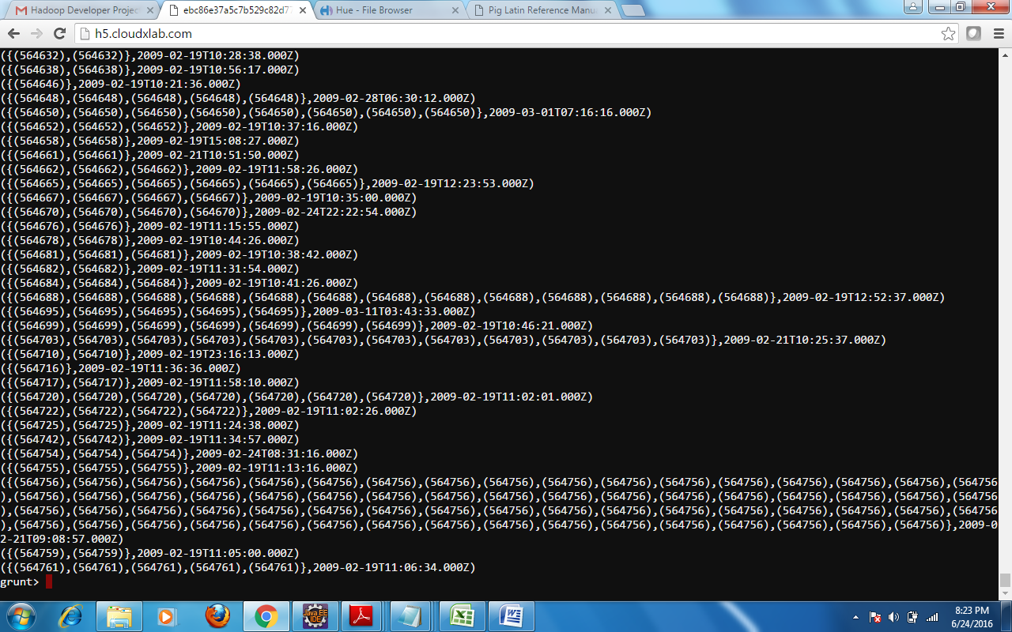

**Question – 3 Number of questions which got answered within 1 hour**

**Solution – 3**

**Pig Script –**

questions_data = LOAD '/user/ebc86e37a5c7b529c82d77dbb24392/VinayT/Datafiles/answers.txt' USING PigStorage('_') AS (qid:chararray,c2:chararray,c3:chararray,c4:chararray,c5:chararray,c6:chararray,c7:chararray,c8:chararray,c9:chararray,c10:chararray,at:long);

qid_at = FOREACH questions_data GENERATE qid as q, ToDate((long)at*1000) as time;

qid_gethour = FOREACH qid_at GENERATE q as q, time as time, GetHour(time) as hour;

qid_hourless1 = FILTER qid_gethour by hour <= 1;

DUMP qid_hourless1;

Output –



**Question – 4 Tags of questions which got answered within 1 hour**

**Solution – 4**

**Pig Script –**

questions_data = LOAD '/user/ebc86e37a5c7b529c82d77dbb24392/VinayT/Datafiles/answers.txt' USING PigStorage('_') AS (qid:chararray,c2:chararray,c3:chararray,c4:chararray,tags:chararray,c6:chararray,c7:chararray,c8:chararray,c9:chararray,c10:chararray,at:chararray);

tags_data_qid_time = FOREACH questions_data GENERATE tags, qid as q, ToDate((long)at*1000) as time;

tags_seperated_with_hour = FOREACH tags_data_qid_time GENERATE TOKENIZE(tags), q as q, GetHour(time) as hour;

tags_flatten = FOREACH tags_seperated_with_hour GENERATE FLATTEN($0) AS tag, q as q, hour as hour;

tags_lessthanonehour = FILTER tags_flatten by hour <= 1;

tags_order = ORDER tags_lessthanonehour by tag;

DUMP tags_order;

**Output –**

